October 30, 2020

Medicaid Nursing Facility Providers

Dear Sir/Madam:

RE: Michigan Department of Health and Human Services (MDHHS) Designated Care and Recovery Center-Removal of Deadline

Care and Recovery Centers (CRCs) are central to MDHHS’ response to the coronavirus pandemic in Michigan. CRCs play a critical role in creating additional health system capacity for the treatment of COVID positive patients, especially when hospital capacity is strained, as well as providing options for other nursing facilities that do not have the capacity to care for residents with COVID-19.

To ensure that MDHHS’ strategy is responsive to changing conditions within the state, the initial October 16th deadline for applications has been removed. Interested nursing facilities are encouraged to apply as soon as possible.

The CRC application details are provided below. It is advised that applicants utilize the Care and Recovery Center Application Checklist to ensure the submission of a complete application packet. Failure to provide required documentation will delay the review of your facility’s application.

Application Details:
- Access application: here
- Questions may be submitted to: MDHHS-CareAndRecoveryCenters@michigan.gov
- CRC operational guidance and protocols can be found here

Sincerely,

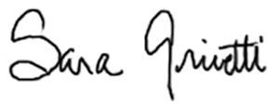
Sara Grivetti, PhDc, State Bureau Director
Bureau of Long-Term Care Services and Support

